WHEEL 1-

|  |  |
| --- | --- |
| Maximum Stress | 3.4 * 10^5 MPa |
| Minimum Stress | 0.774MPa |

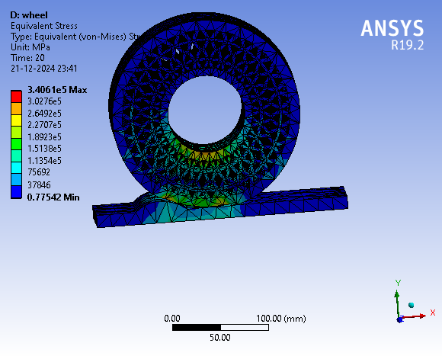

Comment-

WHEEL 2-

|  |  |
| --- | --- |
| Maximum Stress | 6.55 *10^5MPa |
| Minimum Stress | 0.0015MPa |

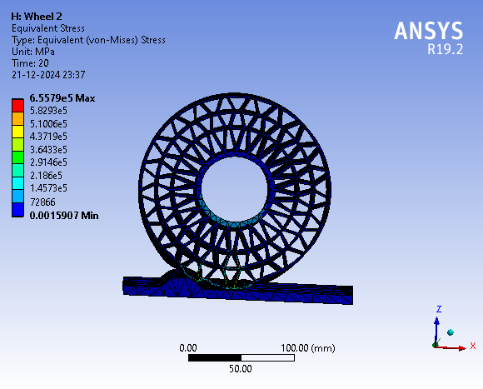

Comment-

WHEEL 3-

|  |  |
| --- | --- |
| Maximun Stress | 4.0112 * 10^5 MPa |
| Minimum Stress | 0.0087 MPa |

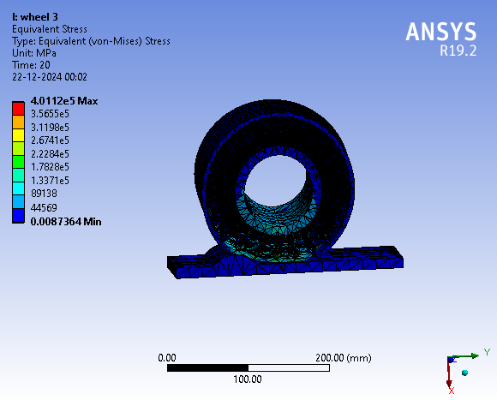

Comment-